ITEC3250

Assignment 2

100 pts

Due 9/17

Dr. Jonathan Jenkins
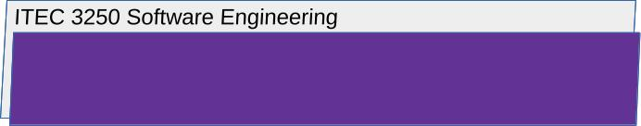

Requirements

1 Notes

- None

What to Submit
See below.

2 Part 1: Requirements Engineering

- If your full name fits alphabetically (last name, first name) at or before the 17th student in the D2l classlist, make a post in the discussion for this assignment that meets the following requirements
  - Briefly describe the steps you take in completing one short task using a software system you have access to, and briefly describe the type of the software system. Include what you see, hear, etc.., but exclude from the post any images or other data that reveal what specific software system you are using (e.g. Microsoft Word, etc.).
- If your full name fits alphabetically after the 17th student in the D2l classlist, make a post in the discussion for this assignment that meets the following requirements
  - Reply to any student that has posted a task description, and using their description post a functional or non-functional system requirement of the system they described
You’ll need to state what the system ‘does’ or ‘is’ in order to make it possible for the original poster to do what they described, including computation, processing, arithmetic, displaying on screen elements, etc.
  - You can reply to students that have already received replies if necessary, but reply to a student that has not received replies as a first option.

3 Part 2: System Modeling

- Regarding the software system you have posted or replied about for Part 1, include near the bottom of your post for part 1:

- A use case diagram that captures at least two use cases for the software system

- A sequence diagram for one interaction with the software system

3 Submission
For all assessment submissions:

- Latest scoreable submission is scored
- Requirement: download or retrieve your submission after you submit it in order to check that all content is as you intend to be scored
- For every assignment, create new content to produce the submission. See the syllabus regarding use of old work

For submissions to submission folders:

- Submit using the submission folder in D2L for this assignment
- Resubmission is possible while the folder is open

